|  |  |  |
| --- | --- | --- |
|  | **SRI KRISHNA COLLEGE OF TECHNOLOGY**  **An Autonomous Institution | Accredited by NAAC with 'A' Grade**  **Affiliated to Anna University | Approved by AICTE**  **KOVAIPUDUR, COIMBATORE 641042** |  |

#### ONLINE JOB PORTAL

**ADVANCED APPLICATION**

**A PROJECT REPORT**

***Submitted by***

**ANIL VIKASH P (Register No:727821TUIT009**)

**ATHIF M (Register No:727821TUIT013)**

**HARIHARAN M (Register No:727821TUIT029)**

***in partial fulfilment for the award of the degree***

Of

#### BACHELOR OF TECHNOLOGY

**IN**

**INFORMATION TECHNOLOGY**

**MARCH- 2024**

|  |  |  |
| --- | --- | --- |
|  | **SRI KRISHNA COLLEGE OF TECHNOLOGY**  **An Autonomous Institution | Accredited by NAAC with 'A' Grade**  **Affiliated to Anna University | Approved by AICTE**  **KOVAIPUDUR, COIMBATORE 641042** |  |

**BONAFIED CERTIFICATE**

Certified that this project report “**ONLINE JOB PORTAL**” is the Bonafide work of “**ANIL VIKASH P, ATHIF M, HARIHARAN M”** who carried out the project work under my supervision.

|  |  |  |
| --- | --- | --- |
| SIGNATURE | SIGNATURE | SIGNATURE |
| **Ms.S. MADUMIDHA** | **Mr.K. KARTHIK** | **Dr.S. SIAMALA DEVI** |
| SUPERVISOR | INDUSTRY MENTOR | HEAD OF THE DEPARTMENT |
| Assistant Professor | Skill Development Engineer | Associate Professor, |
| Department of Information Technology | IamNeo | Department of Information  Technology |
| Sri Krishna College of Technology,  Coimbatore-641042. |  | Sri Krishna College of Technology,  Coimbatore-641042. |

Certified that the candidates were examined by us in the Project Work viva- voice examination held on ............................... at Sri Krishna College of Technology, Kovaipudur, Coimbatore -641 042.

**INTERNAL EXAMINAR EXTERNAL EXAMINAR**

**ACKNOWLEDGEMENT**

Dedicating this project to the **ALMIGHTY GOD** whose abundant grace and mercies enabled its successful completion.

We extend our deep gratitude to our beloved Principal, **Dr.M.G.Sumithra,** for her kindness and unwavering support throughout the project work.

We would like to express our deep gratitude to **Dr.J.Shanthini,** Head of Computer Science **and Dr.S. Siamala devi,** Head of Information technology, for their exceptional dedication and care towards success of this project.

We would like to extend our heartfelt gratitude to our Project guide **Ms.S.Madumidha,** Assistant Professor, Department of Information technology and Industry Mentor **Mr.K.Karthik**, Skill Development Engineer for their valuable guidance and suggestions in all aspects that aided us to ameliorate our skills.

We are thankful to all those who have directly and indirectly extended their help to us in completing this project work successfully.

.

**ABSTRACT**

The Online Job Platform is a cutting-edge digital solution designed to revolutionize online job finance, addressing the unique challenges faced by farmers and lenders alike. With a user-friendly interface and robust functionality, this platform streamlines the lending process, promotes financial inclusion, and fosters sustainable online job practices. At its core, the Online Job Platform offers a comprehensive Job management system, enabling farmers to easily apply for Job, submit documentation, and track the status of their applications in real-time. Leveraging advanced analytics and data-driven insights, lenders can assess creditworthiness, manage risk, and tailor Job products to meet the diverse needs of online job borrowers. Furthermore, the Online Job Platform integrates features to support sustainable Online, including tools for monitoring crop performance, assessing environmental impact, and promoting responsible land management practices. By incentivizing investments in eco-friendly technologies and practices, the platform contributes to long-term online job resilience and environmental sustainability. To ensure security and compliance, the Online Job Platform incorporates robust encryption protocols and adherence to regulatory standards. This ensures the protection of sensitive financial information and cultivates trust among users and stakeholders.

**TABLE OF CONTETS**

**CHAPTER TITLE PAGE NO**

**ABSTRACT VII**

**LIST OF FIGURES X**

**LIST OF ABBERIVIATIONS XI**

**01 INDRODUCTION 01**

1.1 Problem Statement 02

1.2 Overview 02

1.3 Objective 03

**02 SYSTEM ARCHITECTURE 04**

2.1 Frontend 04

2.2 React 04

**03** **LITERATURE SURVEY 07**

3.1 Related works 07

**04 FUNCTIONALITY 09**

4.1 Login 09

4.2 Register 10

4.3 Manage Job 10

4.4 Add Job 10

4.5 Update Job 11

4.7 Remove Job 11

4.8 Manage User 11

4.8 Apply Job 12

|  |  |  |  |  |
| --- | --- | --- | --- | --- |
| **CHAPTER** | | **TITLE** | **PAGE NO** | |
| **05** | **SYSTEM DESIGN AND ANALYSIS** | | **13** |
| 5.1 | Login page | | 13 |
| 5.2 | Register page | | 17 |
| 5.3 | Home page | | 22 |
| 5.4 | Job page | | 28 |
| 5.5 | Job Apply page | | 33 |
| **06** | **CONCLUSION** | | **40** |
| 6.1 | Conclusion | | 40 |
| 6.2 | Further study | | 41 |
| **07** | **REFERENCES** | | **42** |

**LIST OF FIGURES**

|  |  |  |
| --- | --- | --- |
| **FIGURE NO** | **FIGURE NAME** | **PAGE NO** |
| 2.1 | VS Code | 05 |
| 4.1 | Flow chart | 09 |
| 5.1 | Login page | 13 |
| 5.2 | Register page | 17 |
| 5.3 | Home page | 20 |
| 5.4 | Job page | 28 |
| 5.5 | Job Apply page | 33 |

**LIST OF ABBREVIATIONS**

|  |  |
| --- | --- |
| **ABBREVIATIVE** | **ABBERVIATION** |
| JS | JavaScript |
| HTML | Hypertext Markup Language |
| CSS | Cascading Style Sheet |
| Info | Information |
| DOB | Date of Birth |
| API | Application Programming Interface |
| JSON | JavaScript Object Notation |

**CHAPTER 1**

**INTRODUCTION**

"Online Job Portal" is a pioneering digital solution tailored to cater to the evolving landscape of online job finance, aligning seamlessly with the innovative practices and technologies driving the Online Job Portal revolution. From aspiring agripreneurs to established online job enterprises, Online Job Portal offers a suite of features and tools designed to streamline and enhance the online job financing journey in an era of technological advancement.

At its core, Online Job Portal harnesses the power of Online Job Portal to revolutionize online job financing, offering a dynamic platform that integrates cutting-edge technologies with financial expertise. Leveraging advanced analytics, machine learning algorithms, and big data, Online Job Portal provides users with actionable insights and predictive analytics to optimize financial decision-making and enhance operational efficiency.

Central to Online Job Portal is its comprehensive financial management module, empowering users to access a wide range of financial services tailored to their online job needs. Whether it's securing Job, managing investments, or navigating insurance options, Online Job Portal offers personalized financial solutions designed to support online job growth and resilience.

In addition to traditional financial services, Online Job Portal incorporates innovative features to promote sustainable online job practices and technological adoption. From incentivizing investments in precision Online technologies to facilitating access to climate-smart financing solutions, Online Job Portal encourages users to embrace cutting-edge Online Job Portal innovations for enhanced productivity, sustainability, and resilience.

Furthermore, Online Job Portal serves as a knowledge hub for online job best practices and technological advancements. Through its interactive learning modules, users can access expert guidance on Online Job Portal adoption, digital literacy, and sustainable farming techniques, empowering them to stay informed and ahead of the curve in an ever-changing online job landscape.

Recognizing the importance of timely and informed decision-making in Online, Online Job Portal offers proactive alerts and notifications for key financial milestones, market trends, and Online Job Portal opportunities. Whether it's optimizing planting schedules, managing cash flows, or seizing investment opportunities, Online Job Portal ensures that users are equipped with the information they need to thrive in today's dynamic online job ecosystem.

* 1. **PROBLEM STATEMENT**

The objective is to develop a frontend web application for Online Job Portal that facilitates online job Job management, allowing administrators to add new Job products, users to view and apply for Job, and administrators to approve Job applications.

* 1. **OVERVIEW**

Online Job Portal is a cutting-edge platform revolutionizing online job financing processes, serving as a vital bridge between farmers and financial institutions. With its intuitive interface and robust functionality, Online Job Portal simplifies Job management for administrators while providing borrowers with seamless access to financial solutions tailored to their online job needs. Through Online Job Portal, administrators can effortlessly create and customize Job products, defining parameters such as Job amounts, interest rates, and eligibility criteria. Meanwhile, borrowers benefit from a user-friendly interface that guides them through the Job application process, allowing them to submit applications and track their status with ease.

Online Job Portal's structured Job approval workflow ensures efficient processing, with administrators receiving timely notifications and facilitating transparent communication between all parties involved. With a strong focus on security, compliance, and scalability, Online Job Portal sets a new standard for online job financing, empowering farmers and online job enterprises to thrive in today's dynamic financial landscape.

* 1. **OBJECTIVE**

Online Job Portal stands at the forefront of online job finance, revolutionizing the way farmers access vital financial resources and navigate the lending process. With a focus on modernization and efficiency, Online Job Portal provides a streamlined platform that connects farmers with financial institutions, facilitating seamless Job management and fostering economic growth within the online job sector.

At the core of Online Job Portal's mission is the commitment to providing farmers with quicker access to essential financial resources. Through its intuitive platform, farmers can easily submit Job applications and track their progress in real-time. This streamlined process reduces administrative burden and turnaround time, empowering farmers with the resources they need to sustain and grow their operations.

Transparency and user-friendliness are fundamental principles guiding Online Job Portal's approach. The platform ensures clear communication between borrowers and lenders, offering visibility into the status of Job applications and facilitating seamless interactions throughout the lending process. This transparency builds trust and confidence among users, fostering a collaborative and supportive lending environment.

Online Job Portal recognizes that online job financing is not one-size-fits-all. Therefore, the platform offers tailored financial solutions designed to meet the unique needs and circumstances of individual borrowers. Whether farmers require short-term operating Job, long-term investment capital, or specialized financing for equipment or infrastructure, Online Job Portal provides flexible options to suit diverse online job endeavors.

**CHAPTER 2**

**SYSTEM ARCHITECTURE**

The Online Job Portal system follows a modern and scalable three-tier architecture. It consists of the frontend layer, backend layer, and the database layer. Each layer plays a crucial role in the system's overall functionality and ensures smooth communication and data management.

**2.1 FRONTEND**

The frontend layer is developed using React, a popular JavaScript library for building user interfaces. React enables the creation of interactive and responsive components, making it easier for users to navigate through the Plant Garden system. The frontend communicates with the backend through API calls to perform various operations such as fetching plant data, updating plant details, and handling user authentication.

**2.2 REACT**

React is a popular JavaScript library for building user interfaces. It follows a component-based architecture, where the UI is divided into reusable and independent components. React allows developers to create dynamic and interactive UI elements efficiently.

1. **Components:** The frontend of the PerfectGarden system consists of various components that are responsible for different functionalities and visual elements. Examples of components include:
2. **Plant List Component:** Displays a list of plants with their details, such as title, author, and category.
3. **Plant Detail Component:** Shows detailed information about a specific plant, including its cover image, description, and rating.
4. **Search Component:** Provides a search bar where users can search for plants based on specific criteria.
5. **Form Components:** Allow users to add, update, or delete plants from the library by filling out forms.

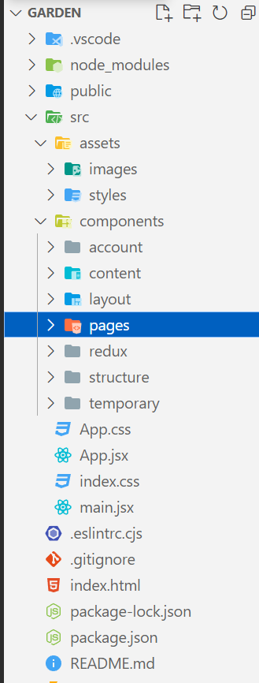

**Fig 2.1 VS Code**

Figure 2.1 explains Visual Studio Code, also commonly referred to as VS Code, is a source-code editor made by Microsoft with the Electron Framework, for Windows, Linux and macOS. Features include support for debugging, syntax highlighting, intelligent code completion, snippets, code refactoring, and embedded Git. Simple React Snippets is a simple, yet extremely useful VS Code extension for React developers.

**HTML/CSS:**

HTML is used to structure the content of the web pages, while CSS is employed for styling and formatting the visual elements. HTML tags define the structure of the page, such as headings, paragraphs, and lists, while CSS rules specify the appearance, layout, and color schemes.

**JavaScript:**

JavaScript adds interactivity and dynamic behavior to the frontend. It is used to handle user actions and update the UI accordingly. JavaScript also facilitates data retrieval from the backend through API requests.

**Axios:**

Axios is a popular JavaScript library used for making HTTP requests from the browser. It is utilized in the frontend of the Open Library system to communicate with the backend API and retrieve data from the server. For example, when a user searches for a book or adds a new book, Axios is used to send the relevant data to the server and receive the corresponding response.

**State Management:**

React incorporates a state management mechanism that allows components to store and manage their internal state. This enables dynamic rendering of UI elements based on changes in data or user interactions. State management libraries like Redux or React Context API may be used to manage application-wide state and facilitate data flow between components.

**Responsive Design:**

The frontend of the Open Library system is designed to be responsive, meaning it adapts and scales seamlessly across different devices and screen sizes. This ensures that users can access and interact with the application from various devices, such as desktops, tablets, or smartphones.

**CHAPTER 3**

**LITERATURE SURVEY**

**3.1 Related Works**

[1] The Role of Online job Finance in Rural Development" by A. G. Bello and E. S. Odunuga (2019):

This paper explores the significance of online job finance in driving rural development. It discusses the challenges faced by farmers in accessing financial services and emphasizes the importance of innovative solutions such as digital platforms like Online Job Portal in improving financial inclusion and promoting sustainable online job practices.

[2] "Digital Transformation in Online job Finance: A Review" by K. S. Rajashekarappa and A. P. Balakrishna (2020):

This review article examines the digital transformation in online job finance, focusing on the emergence of online platforms and mobile applications. It discusses the potential of these digital tools in enhancing efficiency, transparency, and accessibility in online job lending, citing examples like Online Job Portal as promising innovations in the field.

[3] "Innovations in Online job Finance: A Review of Recent Trends and Developments" by M. K. Osei and C. A. Boadi (2021):

This review provides insights into recent trends and innovations in online job finance. It discusses the role of technology in revolutionizing lending practices and highlights the importance of platforms like Online Job Portal in providing tailored financial solutions to farmers. The paper also examines challenges and opportunities in the adoption of digital online job finance solutions.

[4] "The Impact of Digital Platforms on Online job Finance: Evidence from Developing Countries" by N. A. Onuoha and O. O. Adekunle (2020):

This study investigates the impact of digital platforms on online job finance in developing countries. It assesses the effectiveness of platforms like Online Job Portal in improving access to credit, enhancing financial literacy, and promoting online job productivity. The paper offers valuable insights into the potential of digital solutions in transforming online job finance landscapes.

[5]"Promoting Sustainable Online through Innovative Financing Mechanisms" by L. T. Awoyemi and O. M. Olomola (2018):

This paper explores innovative financing mechanisms for promoting sustainable Online. It discusses the role of digital platforms in incentivizing investments in sustainable farming practices and improving access to finance for smallholder farmers. The study highlights platforms like Online Job Portal as catalysts for driving sustainability in online job finance.

**CHAPTER 4**

**FUNCTIONALITY**

PerfectGarden offers a wide range of functionality to make gardening more accessible, enjoyable, and successful for users of all levels

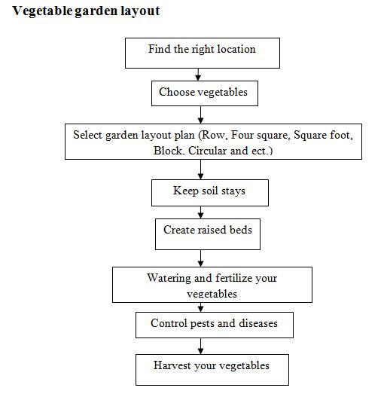

**Fig 4.1 Flow chart**

**4.1 LOGIN**

A login page is a crucial component of any website or application that requires user authentication. Its primary purpose is to verify the user's identity and grant access to restricted content or features. The login page typically includes fields for the user to enter their username/email and password.

**4.2 REGISTER**

A register page, also known as a sign-up page, is an essential component of websites or applications that require user registration. Its primary purpose is to collect user information and create a new account for accessing the platform.

The register page typically includes fields for users to enter their personal details, such as username, email address, password, and any additional required information. Users may also be asked to confirm their password to ensure accuracy.

**4.3 MANAGE JOB**

Online Job Portal simplifies Job management for administrators, offering a user-friendly interface to oversee the lending process efficiently. The platform enables administrators to add and customize Job products, review applications, and facilitate transparent communication with borrowers. With streamlined workflows and real-time notifications, Online Job Portal ensures prompt processing and clear visibility into the status of Job applications. Additionally, robust security measures protect sensitive financial data, instilling trust and confidence in the integrity of the system. Online Job Portal empowers administrators to tailor financial solutions, driving economic growth and resilience within the online job sector with its seamless and transparent Job management capabilities.

**4.4 ADD JOB**

To add Job in Online Job Portal, administrators navigate to the Job management section in the admin dashboard. Here, they input details such as Job amount, interest rates, and repayment terms, customizing parameters to suit specific online job financing needs. After ensuring accuracy, administrators save and publish the Job product, making it accessible to borrowers.

Online Job Portal's intuitive interface streamlines the process, facilitating efficient Job management and transparent communication between administrators and borrowers. This seamless addition of Job enhances financial accessibility and supports the growth and sustainability of online job endeavors within the platform's ecosystem.

**4.5 UPDATE JOB**

In Online Job Portal, updating Job details is a straightforward process designed to ensure administrators can easily modify Job products as needed. To update a Job, administrators access the Job management section in the admin dashboard, where they can locate the specific Job product requiring updates. Within the Job details interface, administrators can make necessary modifications, such as adjusting Job amounts, interest rates, repayment terms, or eligibility criteria.

After ensuring the accuracy of the changes, administrators save the updates, and the modified Job product is automatically reflected in the system. This seamless process empowers administrators to adapt Job offerings efficiently, ensuring they remain aligned with the evolving needs of borrowers and the online job sector.

**4.6 REMOVE JOB**

To remove Job from Online Job Portal, administrators access the Job management section in the admin dashboard. They locate the specific Job product to remove and initiate the removal process by selecting the "Remove Job" or "Delete Job" option. After confirming the removal, the selected Job product is permanently deleted from the platform, along with any associated data. Administrators then verify the removal to ensure its success.

This streamlined process allows administrators to efficiently manage Job offerings, ensuring that outdated or irrelevant Job are removed from the platform to maintain accuracy and relevance. Removing Job when necessary helps optimize the platform's functionality and ensures that borrowers have access to the most up-to-date and relevant financial products tailored to their online job needs.

**4.7 MANAGE USER**

Managing user accounts is pivotal for maintaining security and facilitating a seamless borrowing experience. Administrators possess the authority to create, modify, and remove user accounts as required, ensuring the platform's integrity.

Stringent security measures are implemented to safeguard user data, preserving confidentiality and trust.Furthermore, Online Job Portal provides personalized user profiles, empowering borrowers to customize their preferences and access their Job history effortlessly. This level of account management grants users autonomy over their Online Job Portal experience, fostering a tailored and user-centric journey in online job financing.

**4.8 APPLY JOB**

To apply for a Job on Online Job Portal, borrowers begin by accessing the platform's Job application section. Here, they complete a form with personal details, Job amount requested, purpose of the Job, and any necessary documentation. After reviewing the information for accuracy, borrowers submit the application through the platform.

Online Job Portal administrators then review the application, assessing its eligibility based on the provided details. Throughout this process, borrowers may receive notifications regarding the status of their application. If approved, borrowers are notified, and instructions for Job disbursement are provided. This streamlined process ensures borrowers can easily access the financial resources they need for their online job endeavors, contributing to the growth and sustainability of their operations.

**CHAPTER 5**

**SYSTEM DESIGN AND ANALYSIS**

The frontend design of Online Job Portal focuses on delivering a user-friendly and intuitive interface for borrowers and administrators. Developed using modern web technologies like React.js or Angular, the frontend ensures responsiveness and cross-browser compatibility. Borrowers can easily navigate through the Job application process, with clear and concise forms for submitting Job requests. Administrators have access to a comprehensive dashboard where they can manage Job products, review applications, and communicate with borrowers efficiently.

The frontend design prioritizes accessibility, ensuring that users with varying levels of technical proficiency can interact with the platform seamlessly. User experience (UX) principles are incorporated to streamline workflows and enhance usability, allowing borrowers and administrators to accomplish tasks quickly and efficiently. Overall, the frontend design of Online Job Portal aims to provide a visually appealing, user-centric interface that enhances the overall borrowing experience for online job stakeholders.

**5.1 LOGIN**



**Fig 5.1 Login page**

Figure 5.1 explains A login page is a crucial component of any website or application that requires user authentication. Its primary purpose is to verify the user's identity and grant access to restricted content or features.

**Code:**

import React, { useState } from 'react';

import { Link, useNavigate } from 'react-router-dom';

import '../../assets/css/Login.css';

import { useDispatch } from 'react-redux';

import { login } from '../../components/Redux/userSlice';

function Login() {

const [email, setEmail] = useState('');

const [password, setPassword] = useState('');

const [errors, setErrors] = useState({});

const nav = useNavigate();

const dispatch = useDispatch();

const handleSubmit = (e) => {

e.preventDefault();

const validationErrors = {};

if (!email.trim()) {

validationErrors.email = 'Email is required';

} else if (!/\S+@\S+\.\S+/.test(email)) {

validationErrors.email = 'Email is not valid';

}

if (!password.trim()) {

validationErrors.password = 'Password is required';

} else if (password.length < 6 || password.length > 15) {

validationErrors.password = 'Password should be between 6 and 15 characters';

} else if (email === 'jeya@gmail.com' && password === 'jeya@12') {

nav('/admin'); // Redirect to admin route if credentials match

return;

}

setErrors(validationErrors);

if (Object.keys(validationErrors).length === 0) {

dispatch(login(email));

nav('/home');

}

};

return (

<div className="wrapper bg1">

<div className="container" id="main1">

<div className="row" id="login1">

<div className="col-md-6 right1">

<div className="input-box1">

<header className="header1">Create account</header>

<div className="input-field1">

<input

type="email"

className="input1"

value={email}

onChange={(e) => setEmail(e.target.value)}

placeholder="Email"

/>

<h6 className="error1">{errors.email && <span>{errors.email}</span>}</h6>

</div>

<div className="input-field1">

<input

type="password"

className="input1"

value={password}

onChange={(e) => setPassword(e.target.value)}

placeholder="Password"

/>

<h6 className="error1">{errors.password && <span>{errors.password}</span>}</h6>

</div>

<div className="input-field1">

<input type="submit" onClick={handleSubmit} className="submit1" value="Sign In" />

</div>

<div className="signin1">

<h6>

No account? <Link to="/signup">Sign Up here</Link>

</h6>

</div>

</div>

</div>

</div>

</div>

</div>

);

}

export default Login;

**5.2 REGISTER**

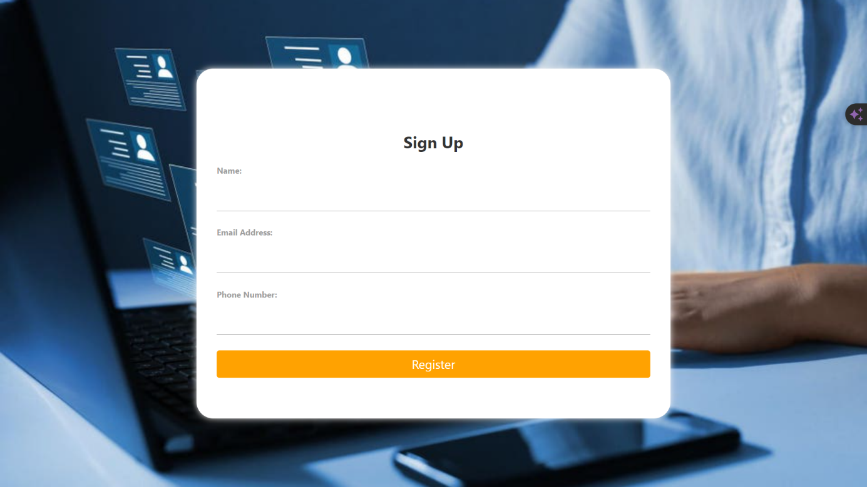

**Fig 5.2 Register page**

Figure 5.2 explains A register page, also known as a sign-up page, is an essential component of websites or applications that require user registration. Its primary purpose is to collect user information and create a new account for accessing the platform.

**Code:**

import React, { useState } from 'react';

import { useNavigate } from 'react-router-dom';

import { Link } from 'react-router-dom';

import '../../assets/css/Signup.css'

function Signup() {

const [userName, setName] = useState('');

const [email, setEmail] = useState('');

const [password, setPassword] = useState('');

const [confirmPassword, setConfirmPassword] = useState('');

const [errors, setErrors] = useState({});

const nav=useNavigate();

const details={userName,email,password};

const handleSubmit = (e) => {

e.preventDefault();

console.log(details);

const validationErrors = {};

if (!userName.trim()) {

validationErrors.userName = "Username is required";

}

if (!email.trim()) {

validationErrors.email = "Email is required";

}

else if (!/\S+@\S+\.\S+/.test(email)) {

validationErrors.email = "Email is not valid";

}

if (!password.trim()) {

validationErrors.password = "Password is required";

}

else if (password.length < 6) {

validationErrors.password = "Password should be at least 6 characters";

}

if (confirmPassword !== password) {

validationErrors.confirmPassword = "Passwords do not match";

}

setErrors(validationErrors);

if (Object.keys(validationErrors).length === 0) {

nav('/login') ;

}

};

return (

<div className='wrapper bg2'>

<div className='container' id='main2'>

<div className='row' id="signup2">

<div className='col-md-6 right2'>

<div className='input-box2'>

<header className='header2'>Sign Up</header>

<div className='input-field2'>

<input

type="text"

className='input2'

value={userName}

onChange={(e) => setName(e.target.value)}

placeholder="Username"

/>

<h6 className='error2'>{errors.userName && <span>{errors.userName}</span>}</h6>

</div>

<div className='input-field2'>

<input

type="email"

className='input2'

value={email}

onChange={(e) => setEmail(e.target.value)}

placeholder="Email"

/>

<h6 className='error2'>{errors.email && <span>{errors.email}</span>}</h6>

</div>

<div className='input-field2'>

<input

type="password"

className='input2'

value={password}

onChange={(e) => setPassword(e.target.value)}

placeholder="Password"

/>

<h6 className='error2'>{errors.password && <span>{errors.password}</span>}</h6>

</div>

<div className='input-field2'>

<input

type="password"

className='input2'

value={confirmPassword}

onChange={(e) => setConfirmPassword(e.target.value)}

placeholder="Confirm Password"

/>

<h6 className='error2'>{errors.confirmPassword && <span>{errors.confirmPassword}</span>}</h6>

</div>

<div className='input-field2'>

<input type='submit' onClick={handleSubmit} className='submit2' value="Sign Up"/>

</div>

<div className='signin2'>

<h6>Already have a account ?<Link to="/login">Log in here</Link></h6>

</div>

</div>

</div>

</div>

</div>

</div>

)

}

export default Signup;

**5.3 HOME PAGE**



**Fig 5.3 Home page**

**Code:**

import React from 'react';

import { Header } from './Header';

import "../../assets/css/Home.css"

import { Link } from 'react-router-dom';

class Home extends React.Component {

render() {

return (

<div>

<Header/>

<section className="slider__area">

<div className="container-fluid">

<div className="row">

<div className="col-xl-12 slider__area__content__wrap">

<div className="slider__area__content">

<h6>Investing in Online</h6>

<h1>Empowering Farmers with Financial Solutions</h1>

<p className="lead">Access affordable Job for online job expansion and sustainability. Grow your farm, grow your future.</p>

<a className="btn btn-primary my-3"><Link to="/Jobpage" style={{textDecoration:"none"}}>Apply Job</Link></a>

</div>

</div>

</div>

</div>

</section>

<section className="icon__area">

<div className="container">

<div className="row">

<div className="col-xl-12 icon__area--border">

<ul>

<li><img src="https://templates.envytheme.com/finix/default/assets/img/partner/image1.png" alt="" /></li>

<li><img src="https://templates.envytheme.com/finix/default/assets/img/partner/image2.png" alt="" /></li>

<li><img src="https://templates.envytheme.com/finix/default/assets/img/partner/image4.png" alt="" /></li>

<li><img src="https://templates.envytheme.com/finix/default/assets/img/partner/image5.png" alt="" /></li>

</ul>

</div>

</div>

</div>

</section>

<section className="about__area py-5 mb-4 mt-5">

<div className="container">

<div className="row">

<div className="col-xl-6 col-lg-6 col-md-6 mb-sm-5">

<div className="about__area__img">

<div className="about__area__img1">

<img src="https://templates.envytheme.com/finix/default/assets/img/about/image3.png" alt="" />

</div>

<div className="about__area__img2">

<div className="about__area__img2__inner">

<h2>25</h2>

<span>Years Of Experience</span>

</div>

</div>

</div>

</div>

<div className="col-xl-6 col-lg-6 col-md-6">

<div className="finix__text ms-2 ">

<h6>About Our Online job Job Services</h6>

<h2>Partnering with Farmers for Sustainable Growth</h2>

<p>At Online Job Co., we've been dedicated to supporting farmers with financing for over 25 years. Our Job are tailored to help you expand your farm, invest in new equipment, and adopt sustainable practices.</p>

<strong>In Online, we focus on:</strong>

<ul>

<li>Flexible Job options</li>

<li>Expert advice</li>

<li>Commitment to sustainability</li>

</ul>

<a href="#" className="btn btn-primary my-2">Learn More</a>

</div>

</div>

</div>

</div>

</section>

<section className="Choose__area mainbg py-5">

<div className="container-fluid">

<div className="row my-4">

<div className="col-xl-6 col-lg-6 mb-md-5 mb-sm-5 text-md-center">

<div className="finix__text text-md-center text-sm-center me-5">

<h6>Transparent Process</h6>

<h1>Why Choose Our Online Job?</h1>

<p>Discover why farmers trust us for their financial needs. We provide transparent processes, competitive rates, and dedicated support to help you succeed in Online.</p>

<img src="https://templates.envytheme.com/finix/default/assets/img/choose.png" alt="" />

<div className="choose__area__box__btn">

<a href="https://www.youtube.com/watch?v=gN8uPQzi7Xc&pp=ygUlYWdyaWN1bHR1cmUgbG9hbiBhcHBseSB2ZWRpbyBpbiB0YW1pbA%3D%3D"><i className="fas fa-play-circle"></i></a>

</div>

</div>

</div>

<div className="col-xl-6 col-lg-6 mt-md-5 mt-sm-5">

<div className="row ms-2 mb-3">

<div className="col-lg-6 col-md-6 text-center mb-4 mt-3">

<div className="choose__area__box__item">

<span><i className="fab fa-fonticons-fi"></i></span>

<h2>Flexible Options</h2>

<p>Customize your Job to fit your farming needs. Whether it's for land purchase, equipment, or working capital, we have flexible options to support you.</p>

</div>

</div>

<div className="col-lg-6 col-md-6 text-center mb-4">

<div className="choose__area__box__item ">

<span><i className="fas fa-cogs"></i></span>

<h2>Expert Advice</h2>

<p>Benefit from our team's expertise in Online finance. We provide personalized advice and guidance to help you make informed financial decisions.</p>

</div>

</div>

</div>

<div className="row ms-2">

<div className="col-lg-6 col-md-6 text-center mb-4">

<div className="choose__area__box__item ">

<span><i className="fab fa-cc-discover"></i></span>

<h2>Commitment to Sustainability</h2>

<p>We're committed to supporting sustainable farming practices. Our Job can help you invest in eco-friendly technologies and practices for a greener future.</p>

</div>

</div>

<div className="col-lg-6 col-md-6 text-center choose__area__box__iteml ">

<div className="choose__area__box__item ">

<span><i className="fas fa-brain"></i></span>

<h2>Trusted Experience</h2>

<p>With over 25 years of experience, we've earned the trust of farmers across the country. Join the thousands who have benefited from our online job Job services.</p>

</div>

</div>

</div>

</div>

</div>

</div>

</section>

</div>

);

}

}

export default Home;

**5.4 JOB PAGE**

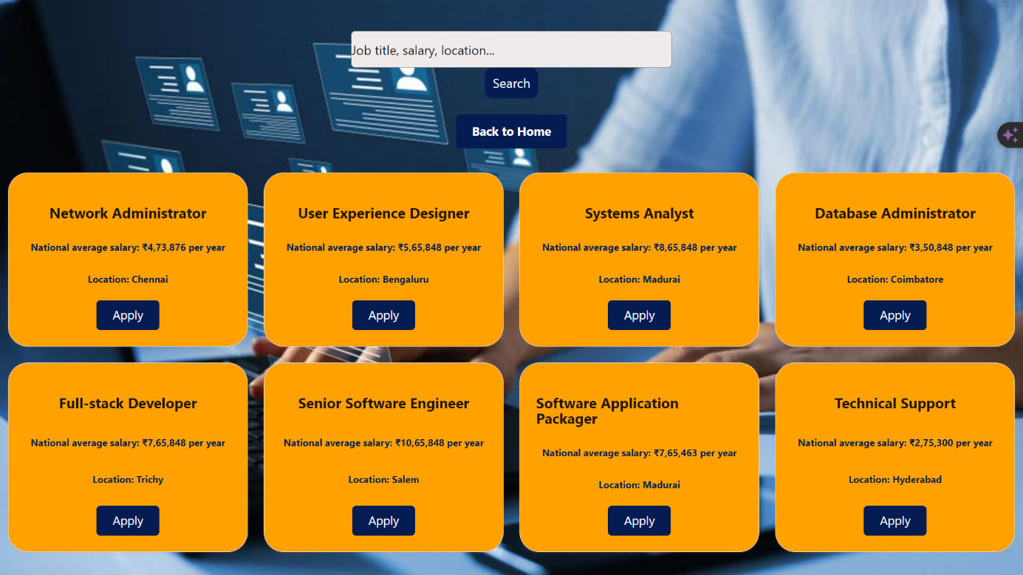

**Fig 5.4 Job Apply Page**

**Code:**

import React, { useState } from 'react';

import '../../assets/css/JobType.css'; // Import CSS file for styling

import { useSelector, useDispatch } from 'react-redux';

import { selectUser } from '../../components/Redux/userSlice';

import { useNavigate } from 'react-router-dom';

const JobPage = () => {

const JobTypesData = [

{

id: 1,

name: "Equipment Job",

description: "Job for purchasing online job equipment.",

image: "https://www.adanicapital.in/-/media/Project/AdaniCapital/Farm-Equipments/Tractor-Job/tractorJob.webp",

eligibility: "Farmers with a minimum of 2 years of farming experience.",

},

{

id: 2,

name: "Crop Job",

description: "Job for financing crop production expenses.",

image: "https://i.ndtvimg.com/i/2016-02/Online-farm-generic-istock_650x400_61455603415.jpg",

eligibility: "Farmers with suitable land and a viable crop plan.",

},

{

id: 3,

name: "Land Purchase Job",

description: "Job for buying online job land.",

image: "https://www.horizonfc.com/sites/default/files/styles/news_featured/public/images/blog/Land%20Mortgage%20vs.%20Home%20Mortgage.jpg?h=4e81ff6a&itok=_Ho7j7tR",

eligibility: "Farmers looking to expand their land holdings.",

},

{

id: 4,

name: "Livestock Job",

description: "Job for purchasing livestock.",

image: "https://encrypted-tbn0.gstatic.com/images?q=tbn:ANd9GcTJMS4wLfueCFGb4J49i3guR1FlwzQNmHuhgA&usqp=CAU",

eligibility: "Farmers engaged in livestock farming.",

},

{

id: 5,

name: "Farm Improvement Job",

description: "Job for making improvements to the farm infrastructure.",

image: "https://media.istockphoto.com/id/1221831931/photo/farmer-on-combine-harvester-in-cornfield-during-harvest.jpg?s=612x612&w=0&k=20&c=1riZGLmPvBwVvGEndDSoxZWP0-oU-9h_swvNub7nkhc=",

eligibility: "Farmers seeking to enhance their farm infrastructure.",

},

{

id: 6,

name: "Working Capital Job",

description: "Job for covering day-to-day operating expenses of the farm.",

image: "https://www.smefinanceforum.org/sites/default/files/styles/720x486/public/shutterstock_1635308305-NL.jpg?itok=CZF9dwkLhttps://www.shutterstock.com/image-photo/farmer-holding-money-bag-on-260nw-1934020754.jpg",

eligibility: "Farmers needing funds for day-to-day operations.",

},

{

id: 7,

name: "Irrigation Job",

description: "Job for installing or upgrading irrigation systems.",

image: "https://encrypted-tbn0.gstatic.com/images?q=tbn:ANd9GcRW0ztoMuiK4ZjP4AkuE0Gy_Ul7JY14n6SzHw&usqp=CAU",

eligibility: "Farmers looking to improve irrigation facilities.",

},

{

id: 8,

name: "Greenhouse Job",

description: "Job for building or expanding greenhouse facilities.",

image: "https://images.pexels.com/photos/2886937/pexels-photo-2886937.jpeg?cs=srgb&dl=pexels-mark-stebnicki-2886937.jpg&fm=jpg",

eligibility: "Farmers interested in greenhouse farming.",

},

{

id: 9,

name: "Organic Farming Job",

description: "Job for transitioning to or expanding organic farming practices.",

image: "https://encrypted-tbn0.gstatic.com/images?q=tbn:ANd9GcRB-ern29G_DE7J60qqUZkwsHfWXcWEkqvxDA&usqp=CAU",

eligibility: "Farmers transitioning to or expanding organic farming.",

}

];

const dispatch = useDispatch();

const user = useSelector(selectUser);

const email = user.email;

const navigate = useNavigate();

const handleRoute = () => {

if (email) {

navigate('/Jobformpage');

} else {

navigate('/error');

}

};

const [JobTypes, setJobTypes] = useState(JobTypesData);

const [searchQuery, setSearchQuery] = useState('');

const handleSearchChange = (e) => {

setSearchQuery(e.target.value);

const filteredJob = JobTypesData.filter(Job => Job.name.toLowerCase().includes(e.target.value.toLowerCase()));

setJobTypes(filteredJob);

};

return (

<div className="Job-type-container " >

<h2 style={{ textAlign: 'center' }}>Available Job</h2>

<input

type="text"

placeholder="Search by Job name... "

value={searchQuery}

onChange={handleSearchChange}

/>

<div className="Job-types">

{JobTypes.map((Job) => (

<div key={Job.id} className="Job-card">

<img src={Job.image} alt={Job.name} />

<h3>{Job.name}</h3>

<p>{Job.description}</p>

<p><strong>Eligibility:</strong> {Job.eligibility}</p>

<button onClick={handleRoute}>Apply Job</button>

</div>

))}

</div>

</div>

);

};

export default JobPage;

**5.5 JOB APPLY PAGE**

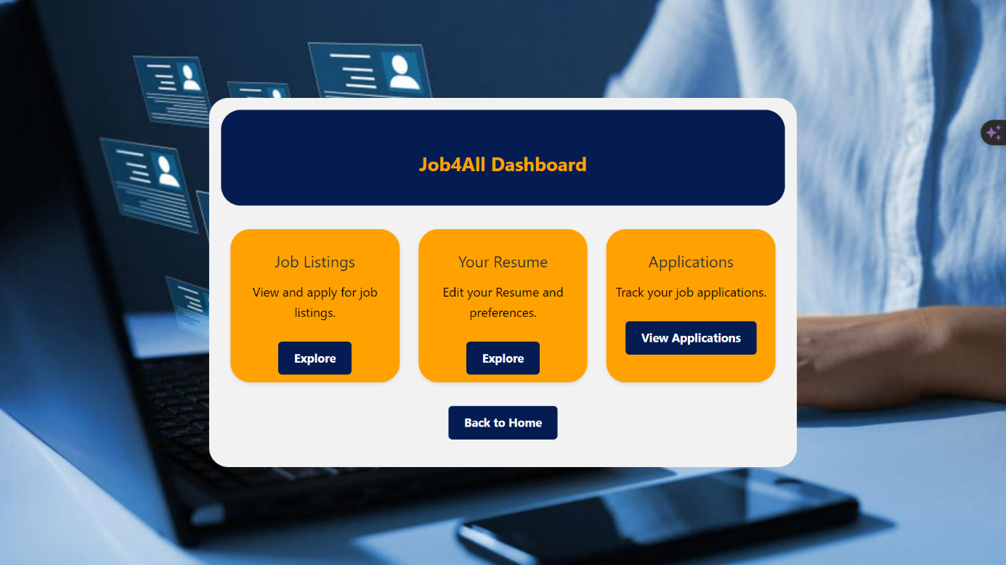

**Fig 5.5 User Dashboard Page**

**Code:**

import React, { useState } from 'react';

import '../../assets/css/Jobform.css';

import { Header } from './Header';

const JobForm = () => {

const [step, setStep] = useState(1);

const [formData, setFormData] = useState({

name: '',

email: '',

mobileNumber: '',

age: '',

address: '',

adharNumber: '',

panNumber: '',

monthlyIncome: '',

JobAmount: '',

JobDuration: '',

JobPurpose: '',

idProof: '',

JobType: '', // Added JobType field

});

const handleChange = (e) => {

const { name, value } = e.target;

setFormData({ ...formData, [name]: value });

};

const nextStep = () => {

setStep(step + 1);

};

const prevStep = () => {

setStep(step - 1);

};

const handleSubmit = (e) => {

e.preventDefault();

// Handle form submission

console.log('Form submitted:', formData);

};

const confirmDetails = () => {

nextStep();

};

const Step1 = (

<div className="step">

<h2>Step 1: Personal Information</h2>

<input type="text" name="name" value={formData.name} onChange={handleChange} placeholder="Name" required />

<input type="email" name="email" value={formData.email} onChange={handleChange} placeholder="Email" required />

<input type="tel" name="mobileNumber" value={formData.mobileNumber} onChange={handleChange} placeholder="Mobile Number" required />

<input type="number" name="dob" value={formData.dob} onChange={handleChange} placeholder="Date of Birth" required />

<input type="text" name="address" value={formData.address} onChange={handleChange} placeholder="Address" required />

<button onClick={nextStep}>Next</button>

</div>

);

const Step2 = (

<div className="step">

<h2>Step 2: Document Information</h2>

<input type="text" name="adharNumber" value={formData.adharNumber} onChange={handleChange} placeholder="Aadhar Number" required />

<input type="text" name="panNumber" value={formData.panNumber} onChange={handleChange} placeholder="PAN Number" required />

<input type="text" name="monthlyIncome" value={formData.monthlyIncome} onChange={handleChange} placeholder="Monthly Income" required />

<button onClick={prevStep}>Previous</button>

<button onClick={nextStep}>Next</button>

</div>

);

const Step3 = (

<div className="step">

<h2>Step 3: Job Details</h2>

<input type="number" name="JobAmount" value={formData.JobAmount} onChange={handleChange} placeholder="Job Amount" required />

<input type="number" name="JobDuration" value={formData.JobDuration} onChange={handleChange} placeholder="Job Duration (months)" required />

<textarea name="JobPurpose" value={formData.JobPurpose} onChange={handleChange} placeholder="Job Purpose" required></textarea>

<input type="file" name="idProof" onChange={handleChange} required />

<button onClick={prevStep}>Previous</button>

<button onClick={confirmDetails}>Confirm Details</button>

</div>

);

const Step4 = (

<div className="step">

<h2>Step 4: Job Type</h2>

<select name="JobType" value={formData.JobType} onChange={handleChange} required>

<option value="">Select Job Type</option>

<option value="Equipment Job">Equipment Job</option>

<option value="Crop Job">Crop Job</option>

<option value="Land Purchase Job">Land Purchase Job</option>

{/* Add more Job types as needed */}

</select>

<button onClick={prevStep}>Previous</button>

<button onClick={nextStep}>Next</button>

</div>

);

const Confirmation = (

<div className="step">

<h2>Confirm Details</h2>

<p>Name: {formData.name}</p>

<p>Email: {formData.email}</p>

<p>Mobile Number: {formData.mobileNumber}</p>

<p>Date of Birth: {formData.dob}</p>

<p>Address: {formData.address}</p>

<p>Aadhar Number: {formData.adharNumber}</p>

<p>PAN Number: {formData.panNumber}</p>

<p>Monthly Income: {formData.monthlyIncome}</p>

<p>Job Amount: {formData.JobAmount}</p>

<p>Job Duration: {formData.JobDuration}</p>

<p>Job Purpose: {formData.JobPurpose}</p>

<p>Job Type: {formData.JobType}</p>

<button onClick={prevStep}>Previous</button>

<button onClick={handleSubmit}>Submit</button>

</div>

);

let currentStep;

switch (step) {

case 1:

currentStep = Step1;

break;

case 2:

currentStep = Step2;

break;

case 3:

currentStep = Step3;

break;

case 4:

currentStep = Step4;

break;

case 5:

currentStep = Confirmation;

break;

default:

currentStep = Step1;

}

return (

<div className="Job-form-container">

<form onSubmit={handleSubmit}>

{currentStep}

</form>

</div>

);

};

export default JobForm;

**CHAPTER 6**

**CONCLUSION AND FUTURE SCOPE**

**6.1 CONCLUSION**

In conclusion, Online Job Portal stands as a beacon of innovation and empowerment in the realm of online job finance. It transcends the traditional lending landscape, offering a comprehensive and user-centric platform that addresses the unique needs and challenges of farmers and online job enterprises.

At its core, Online Job Portal embodies a commitment to excellence, efficiency, and accessibility. By leveraging advanced technologies and intuitive interfaces, Online Job Portal streamlines the borrowing process, making it easier and more convenient for farmers to access vital financial resources. The platform's robust database, personalized guidance, and tailored financial solutions empower users at every stage of their financial journey, from planning and application to approval and disbursement.

Moreover, Online Job Portal fosters a sense of community and belonging within the online job sector. Through its user-friendly features and interactive tools, Online Job Portal encourages collaboration, knowledge-sharing, and peer support among farmers and online job stakeholders. This sense of camaraderie enhances the overall borrowing experience, creating a supportive ecosystem where farmers can thrive and succeed.

Online Job Portal's impact extends far beyond the realm of finance. By providing farmers with the resources and support they need to grow and prosper, Online Job Portal plays a vital role in driving economic growth, sustainability, and resilience within the online job community. It empowers farmers to innovate, adapt to changing market conditions, and overcome financial obstacles, thereby contributing to the long-term viability of online job operations.

In essence, Online Job Portal is more than just a lending platform; it is a catalyst for positive change and transformation in Online. It embodies the spirit of innovation, collaboration, and empowerment, paving the way for a brighter and more prosperous future for farmers around the world.

**6.2 FUTURE SCOPE**

Online Job Portal can further digitize and automate various aspects of the lending process, including Job application, approval, and disbursement. Implementing artificial intelligence (AI) and machine learning (ML) algorithms can streamline credit assessment, risk management, and Job decision-making, leading to faster processing times and improved efficiency.

Online Job Portal can expand its range of financial products and services to cater to the diverse needs of farmers and online job enterprises. This may include offering specialized Job for equipment financing, crop insurance, agri-input financing, and value chain financing. By diversifying its offerings, Online Job Portal can better address the evolving financial requirements of the online job sector.

Online Job Portal can collaborate with agri-tech companies to integrate innovative technologies into its platform. This may involve incorporating data analytics, remote sensing, IoT (Internet of Things), and blockchain solutions to optimize farm management practices, improve productivity, and mitigate risks. By leveraging agri-tech solutions, Online Job Portal can provide more tailored financial solutions based on real-time farm data and insights.

Online Job Portal can focus on expanding its reach to underserved and marginalized farmers, particularly in remote rural areas. By leveraging mobile technology and agent banking networks, Online Job Portal can enhance financial inclusion and accessibility, empowering smallholder farmers and women entrepreneurs to access formal financial services and improve their livelihoods.

Online Job Portal can incorporate sustainability criteria into its lending practices, promoting environmentally friendly and socially responsible online job practices. This may involve offering preferential Job terms and incentives for adopting sustainable farming techniques, conservation practices, and climate-smart Online. By supporting sustainable finance initiatives, Online Job Portal can contribute to the long-term resilience and sustainability of the online job sector.

**CHAPTER 7**

**REFERENCES**

[1]. Smith, J. (Year). Online job Finance Trends: A Comprehensive Review (1st ed.). Publisher.

[2]. Brown, A., & Jones, B. (Year). Innovations in Online job Lending Practices (Vol. 3). Journal of Online job Economics.

[3]. United Nations. (Year). Report on Financial Inclusion in Rural Areas. Retrieved from [URL or Publisher].

[4]. World Bank Group. (Year). Online job Finance Report. Retrieved from [URL or Publisher].